**Bachelor Thesis**

**Framework agnostic Design Systems**

**What restrictions do Web Components impose on an Angular & Tailwind Design System?**

Submitted in partial fulfilment of the requirements for the degree of:

Bachelor of Science in Computer Science

Supervisor: Fabian Gosebrink

If applicable: Co-supervisor: [First Name, last name]

Submitted by:

Remo Kessler

[Address]

Tel.: [telephone number]

E-Mail: [e-mail address]

Submission date: [xx.xx.xxxx]

**Table of Contents**

Abstract / Management Summary 2

1 Introduction 3

1.1 [Subtitle] 3

1.1.1 [Second order subtitle] 3

1.2 [Subtitle] 3

2 Theory 4

3 Method 5

4 Analysis / Results / Findings 6

5 Conclusion 7

References 8

List of Figures & Tables 9

Figures 9

Tables 9

Appendix 10

**Attention - these titles are only exemplary!**

**The declaration of academic integrity is not listed in the table of contents. It is always on the last page.**

# 

# Abstract / Management Summary

# Introduction

Your text, your text

## [Subtitle]

Your text, your text

### [Second order subtitle]

Your text, your text

## [Subtitle]

Your text, your text (Last name, year of publication, p. XY)

Please note our rules for correct citation, which are laid down in the guidelines for citing and referencing.

# Theory

The Bühler Design System currently utilizes Angular and Tailwind to develop components based on an architecture known as Atomic Design. This paper aims to introduce a small set of web components into this design system and evaluate their impact. The intended outcome is to provide a well-defined Architecture Decision Record (ADR) proposal, which will serve as the basis for determining whether to utilize web components in the existing system.

## What is a Design System?

„There isn’t a standard definition of 'design system' within the web community, and people use the term in different ways” (Kholmatova, 2017).

## What are Web Components?

## Atomic Design

## Architecture Decision Record

## Project setup: Innersource

# Method

## Technical Limitations

### Bundlers: Webpack vs EsBuild

In the Angular space are currently two Bundlers to build sourcecode. With both bundlers a Storybook instance with Angular Libraries can be served within an NX MonoRepo (see the attached examples vite and webpack respectively).

However, Hot Module Reloading (HMR) was only achievable with Vite, thanks to the Contribution of Brandon Roberts to AnalogJs <https://analogjs.org/docs/integrations/storybook>, in which he made a working vite plugin for storybook that allows it to render Angular Components via the @analogjs/vite-plugin-angular package.

Configuring Storybook with the Package allows for HMR out of the box, allowing for a smooth developer experience.

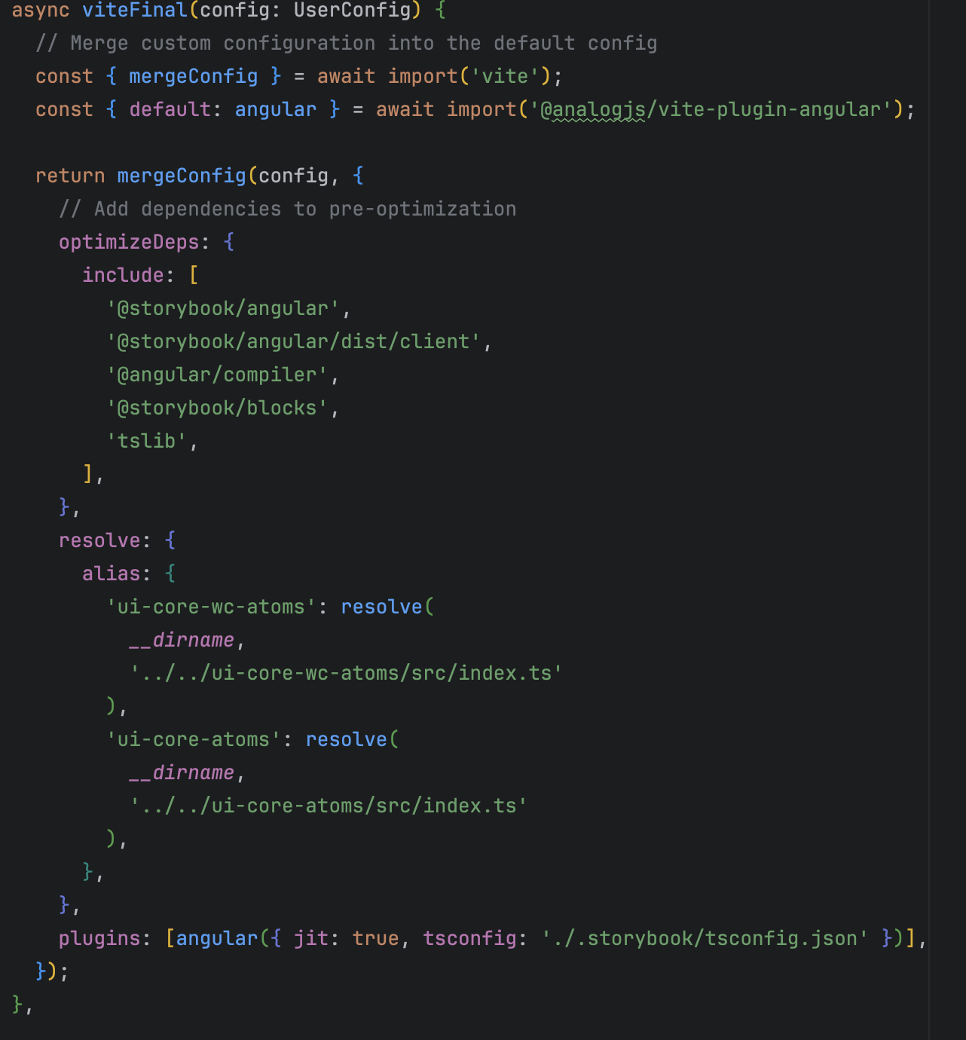

### Prettier

For Code-Formatting prettier is used within Bühler. This works out of the box across all technologies, as this example shows a change within a prettier config getting changes across all file-types and technologies.



### Static Code Analysis

tbd

### Syntax Highlighting

Syntax Highlighting is checked with the two Editors used at Bühler VSCode and WebStorm. Without installing any Plugins WebStorm offers out of the Box Support for WebComponents as well as LitElements.

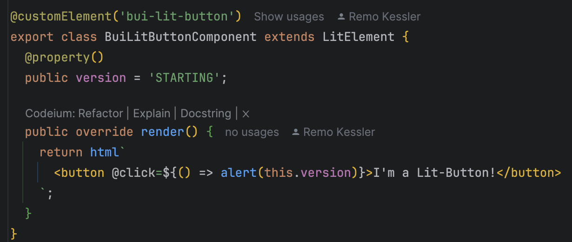

VSCode offers support as well however in order to get Syntax-Highlighting inside the Lit-HTML Tag a Plugin is required. The plugin used in the following image is lit-html <https://marketplace.visualstudio.com/items?itemName=bierner.lit-html>

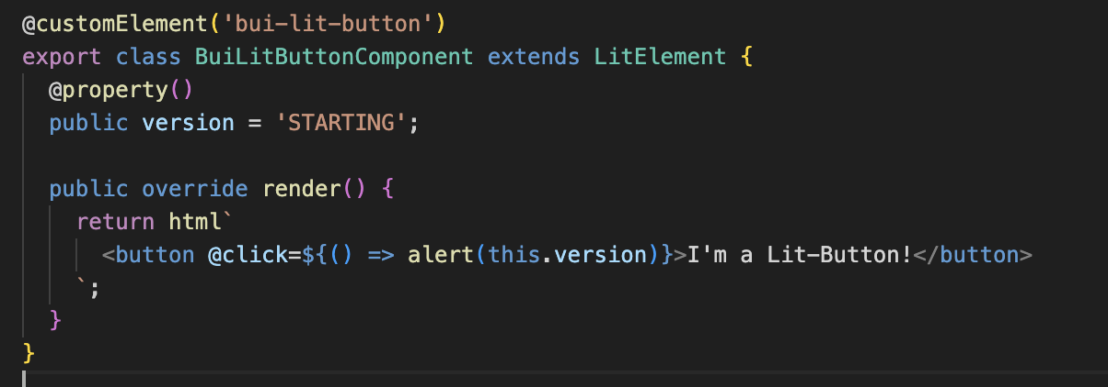

## Tailwind

<https://jordanbrennan.hashnode.dev/8-ways-to-style-the-shadow-dom>

4 Ways to have external styles

1. Inherited Styles (e.g. css variables), watch out for all:initial
2. :root properties
3. ::part 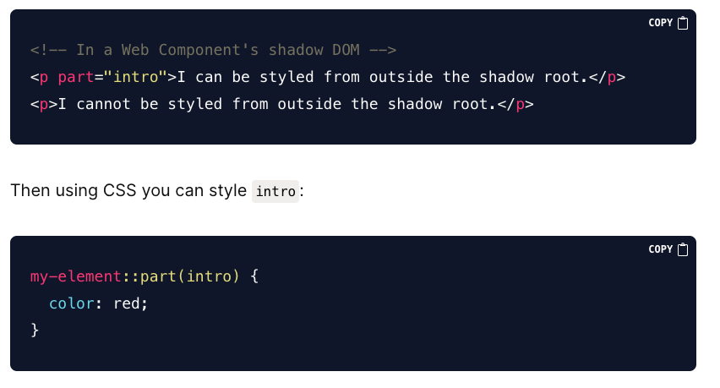
4. Global Stylesheet imports via @import

<https://medium.com/@yesmeno/css-resets-and-global-styles-in-web-components-c71fcea86dbd> Rollup Import

### Approach Load global tailwind into different web-components

## Environment

* Storybook hot reloading does not work
  + Web Components are loaded, but cannot be unloaded thus the page needs to be refreshed
* Syntax Highlighting
  + Works as it’s also typescript
  + Disables template checking when using CUSTOM_ELEMENTS_SCHEMA
* Typing
  + <https://github.com/angular/angular/issues/12045>

## Jest

Doesn’t work as to the conversation with the lit team.

Statement of the LitElements support:

“LitElement requires browser DOM APIs to be available. My understanding is that Jest doesn't provide this out of the box, but it does look like there are a few options, see:

* <https://jestjs.io/docs/puppeteer>
* <https://jestjs.io/docs/tutorial-jquery>

“

Meaning that Web Components can only be component tested and not unit tested.

# Analysis / Results / Findings

# Conclusion

# References

Please note our rules for correct citation, which are laid down in the guidelines for citing and referencing.

# List of Figures & Tables

## Figures

## Tables

# Appendix

If necessary, Appendix with additional information and materials. If there are several appendices, these can be titled either with Appendix A, Appendix B etc. or with Appendix I, Appendix II etc. and each with a content description.

Declaration of Originality

I hereby declare that this assignment is my own work and that I have completed this work without the assistance of others. I have acknowledged all literature and sources used and have cited these in accordance with academic citation conventions. I have documented the use of AI tools transparently.

I have not previously submitted this assignment, or parts thereof, for credit on another course, unless this has been expressly agreed with the relevant instructor.

I am aware that this work may be checked for plagiarism and AI-generated text passages and works – including through the use of relevant software. I hereby specifically authorise Kalaidos University of Applied Sciences to perform such checks.

The work comprises the following number of characters: ________

*Character count: body of the text, excluding the title page, table of contents, preface, abstract/management summary, lists of figures, diagrams, tables, abbreviations and references, appendices and Declaration of Originality. Text fields, footnotes and endnotes need not be counted.*

____________________________ __________________________________

Place, date First name, Surname

__________________________________

Signature

*If the work was created as a piece of group work, this declaration must be submitted in we-form and specify the details of all authors in the section “Surname”, “First name” and “Date of birth”.*